How to add a shortcut to the Republic Mod Loader
METHOD 1 – Pin to taskbar
- Open RML from the workshop folder
- While the loader is open, right click the icon in the task bar. This should bring up an option to “pin to taskbar” *subject to what operating system you are running)
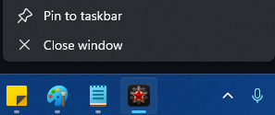
- Select “Pin to taskbar
- When the loader is closed, the icon will remain on the task bar

- To load RML again, just left click the icon.
DONE

METHOD 2 – Make a shortcut
- Go to the RML workshop folder
- Right click the “RepublicModLoader.exe”
- Select “Create a shortcut”. If you are on windows 11, you will need to select “show more options” first
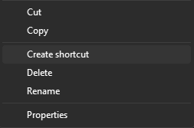
- This will create a direct short cut link icon with a tiny arrow icon.
- Move this shortcut wherever you want such as your desktop.
- To load RML again, just click the shortcut
DONE

